**Report**

**Professional Practice in IT**

**Report**

A Summary of what we did for our professional practice project.

When first given the task to come up with a project for this module we came up with a few ideas of different projects, we wanted a project that we could both work on and have enough components that we could share the tasks.

**Week 1-2**

**20-01-2020**

* Meeting between myself (Michael Mulholland) and Kevin Flanagan.
* We began researching project ideas.
  + 2D Unity Game / 3D Unity Game
    - Ideas like Super Mario, Jetpack Joyride, Robbery Bob
  + CRUD (create – read – update – delete) application
* Our initial ideas but we could not decide on which one to create.

**22-01-2020**

* 1st meeting with our mentor – Kevin O’Brien.
* We received a break-down of the project requirements.
* At this time, we still could not decide on what to do for our project.
* Attendees: Michael Mulholland and Kevin Flanagan.

**27-01-2020**

* 2nd meeting with our mentor – Kevin O’Brien.
* We decided to create a CRUD application in React and use MongoDB to store the data, but we still could not decide on the topic.
* Attendees: Michael Mulholland and Kevin Flanagan.

**29-01-2020**

* Meeting between myself (Michael Mulholland) and Kevin Flanagan.
* Created GitHub repository on [www.github.com](http://www.github.com)
* Name: Professional-Practice-Project
* Added a new milestone and a new issue.
  + Project Idea?
  + Assigned the milestone to myself (Michael Mulholland and Kevin Flanagan)
* Completed on the 05-02-2020

**30-01-2020**

* Meeting between myself (Michael Mulholland) and Kevin Flanagan.
* We ran into complications as we changed our mind on the project because we are in dispute over the project idea.
* Decided to do research over the weekend and to try and have the project idea nailed down by 04-02-2020 (Tuesday).

**Week 3**

**04-02-2020**

* Meeting between myself (Michael Mulholland) and Kevin Flanagan in GMIT Castlebar college.
* Three weeks in and we still cannot agree on what to do for the project.
* I explained to Kevin Flanagan that I have decided to email our mentor to see if I could meet him on the 05-02-2020 to discuss my options.

**05-02-2020**

* 3rd meeting with our mentor – Kevin O’Brien.
* Explained to Kevin O’Brien the situation.
* He informed me that I can do the project on my own.
* I decided that I wanted to create a 3D game in Unity.
* I also said that I would ask Kevin Flanagan if he wanted to work with me on the project.
* I got in contact with Kevin and discussed the situation to him. He said that he will talk to our mentor on Monday the 10th of February before deciding on whether he will work with me on the project or not.
* Attendant: Michael Mulholland.
* Project Idea: 3D game in Unity – something like Jetpack Joyride but a 3D version.

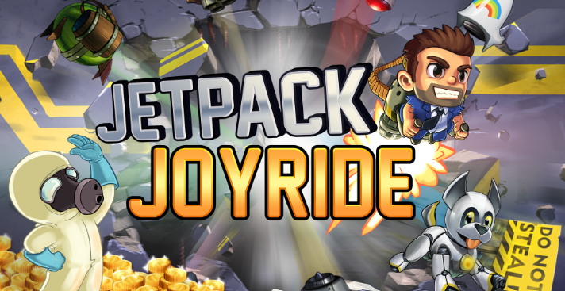 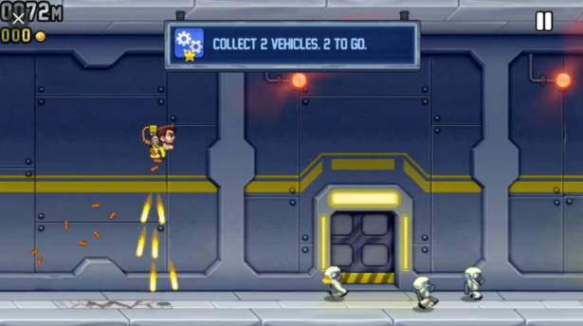

* Created a new GitHub repository on www.github.com
* Name: 3rd-Year-Professional-Practice-Project
* Added a new milestone and a new issue for testing reasons.
  + Project Idea
  + Closed milestone as I had already decided on my project idea.
* Completed on the 05-02-2020
* Added a new milestone and a new issue.
  + Initial Setup – add a floor and a player to the project
* Done some research and then completed the task that I had set myself.
* Completed on the 05-02-2020
* Created a new 3D unity game.
* Name: Professional Practice Project
  + Added:
    - Floor
    - Ceiling
    - Player
* I got the player moving in an upwards direction by pressing and holding the space bar. Once the player releases the space bar, the player falls back to the floor using gravity.

**06-02-2020**

* Added a new milestone and a new issue.
  + Player movement - Allow movement of the player from the left side of the screen to the right side of the screen.
* I finished adding left and right movement to the player and submitted my work to GitHub.
* Completed on the 06-02-2020
* Added a new milestone and a new issue.
  + Player movement along the z-axis - Add Continuous movement of the player in the z-axis without pressing any keys
* I want to have this milestone complete by the 10-02-2020
* Completed on the 07-02-2020

**07-02-2020**

* Implemented player and camera movement along the z-axis.
* Added a new milestone and a new issue.
  + Add obstacles to the game with collision detection.
* I want to have this milestone complete by the 14-02-2020
* Completed on the 09-02-2020

**08-02-2020**

* I have added in two obstacles and implement collision on both. So, if the player collides with either of the obstacles, the player object will be destroyed.
* I tried and failed to restart the scene when the player reaches the end of the scene. This would allow me to only create one scene and I would loop the scene all the time. I am still going to see if I can implement this idea.
* I have the player moving in the z-axis, but I am thinking of changing it. Maybe I will keep the player in the same spot and move the obstacles towards the player.
* I have added a new robot assist to be the player in the game.

**09-02-2020**

* Change of plan. Instead of the player moving in the z-axis towards the obstacles, I have the obstacles spawning at regular intervals and moving towards the player.

**Week 4**

**10-02-2020**

* 3rd meeting with our mentor – Kevin O’Brien.
* Discussed how me (Michael Mulholland) and Kevin Flanagan can work together on the project.
* I will set up a meeting with Kevin Flanagan on the 11-02-2020 to iron things out.
* Attendant: Michael Mulholland – Kevin Flanagan could not attend due to circumstances out of his control.

**11-02-2020**

* Meeting between myself (Michael Mulholland) and Kevin Flanagan.
* We had a good chat about the project, and we decided that we would work together after all.
* We agreed on an idea for the project and I (Michael Mulholland) will no longer be working on the 3d Unity game.
* Our project is now going to be a professional photographer website.
* Here are a few ideas that we might implement in the website:
  + CRUD – Create, Read, Update and Delete application
  + Store data on mongodb
  + Allow the user to buy photos/courses/photographers services
* Kevin is now added to the GitHub repository. I have deleted the 3d unity game from the repository and we will start on the new project on the 12-02-2020.
* Attendees: Michael Mulholland and Kevin Flanagan.

**Week 5**

**17-02-2020**

* Meeting with myself (Kevin Flanagan) and Michael Mulholland and our supervisor Kevin O’Brien.
* We discussed and got the all clear from Kevin for the project.
* After deciding what we would do our project on and researching the technology that we would use to build our site (LAMP) and google platform to host it.
* We decided to add more issues for our GitHub milestones.
* Kevin seems happy with choice for our website and with our progress.
* We have set up a meeting a meeting for the following week.
* Attendees: Kevin Flanagan, Michael Mulholland and Kevin O’Brien

**Week 6**

**24/02/2020**

* Another meeting with Kevin O’Brien today just to discuss the project.
* We discussed using **LAMP** (**L**inux, **A**pache, **M**ySQL, **P**HP/**P**erl/**P**ython)
* Michael asked Kevin about pulling information from a database and importing a file or exporting a file from the database.
* We have set up a meeting between Michael and me (Kevin Flanagan) for tomorrow to discuss any changes in our project
* Discussed GitHub milestones (adding new issues and removing completed ones)
* Attendees: Kevin Flanagan, Michael Mulholland and Kevin O’Brien

**Week 7**

**02/03/2020**

* We had our weekly meeting with Kevin (O’Brien) to discuss any issues with our project.
* Asked us how we were getting on with the project and how we are working together on it.
* Arranged to meet up the following week and to set up a meeting between Michael and myself for tomorrow in the library
* We asked Kevin about a few features we were thinking about adding to our website.
  + Relational Databases
  + Login
* Attendees: Kevin Flanagan, Michael Mulholland and Kevin O’Brien

**Week 8**

**09/03/2020**

* We had our weekly meeting today with our supervisor about the website.
* Kevin asked us about different features on the website and about keeping it consistent the whole way through (Same font and colour scheme)
* We had a few questions for Kevin about some of the programs we would be using to build the database. (Putty and FileZilla) Kevin was very helpful.
* Set up meeting in the library for the following day as we have been doing and set up meeting for the following week with Kevin.
* Attendees: Kevin Flanagan, Michael Mulholland and Kevin O’Brien

**Week 9**

**16/03/2020**

* Unfortunately, this week’s meeting had to be rescheduled for next week due to St. Paddy’s days.
* We still had our meeting in the library to discuss any changes.

**Week 10**

**23/03/2020**

* Unfortunately, there has been an outbreak of covid-19 and college has been suspended for the moment.
* Work continues at home!

**Week 11**

**30/03/2020**

* There has been a change to the set-up now with this pandemic that has been spreading across the world.
* With college suspended we are using emails and video calls to communicate with each other.
* Work still being done on the website and its documentation.
* GitHub has never been more important to share and test our website.
* We have been setting Milestones & Issues on GitHub to keep track of our project.

**Week 12**

**06/04/2020**

* Getting closer to the finishing date we have started testing the website e.g. Login, Register and just the general run of the site and what happens when certain things are done.
* Still using video calls to discuss any problems and have been in contact with Kevin also to discuss changes.
* Different Pages that have been set-up
  + Profile Page
  + Login/Register Page
  + About Page
  + Home Page.
* Images must be displaying on a carousel on the home page when first loaded.
* Storing customers details into a database, setting up SQL queries.

**Week 13**

**13/04/2020**

* With the finishing date coming up fast testing is taking high priority now.

**20/04/2020**

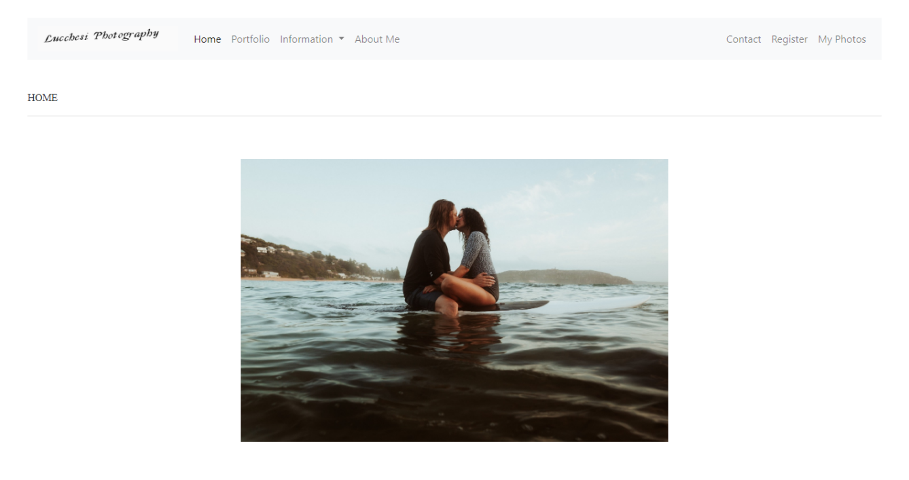Luccchesi Photograph

Completed!